NWCT WILDERNESS CAMP REGISTRATION
JULY 23 –July 25, 2021

Camp Pricing
Registration Deadline July 18, 2021
$25 per teen
___ Number of teens * $25 = ________

___ I would like to donate additional money to help finance the NWCT Mission._______ Total: _______

___Check
(Make payable to NWCT)

___Cash

Student Registration Information
(I need this info for every teen going)
First Name: __________Last:___________

Address:___________________________

City:____________State:_____Zip:______

Phone:____________Cell:_____________

Email:_____________________________

Parents Names:______________________

Male/Female:______Age:_____
Grade he/she will be in for 2021-2022 school year?
Grade:________________School:_____________

NORTHWEST CHRISTIAN TEENS WILDERNESS CAMP
July 23-July 25, 2021

Dear Teens and Parents,

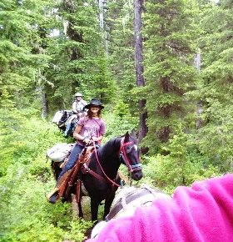
Here’s the information you’ve been waiting for to help you prepare for the greatest 3 days of your summer! Please read all of the enclosed material carefully. If you have any questions, don’t hesitate to call.

To be eligible to attend you must be 11 years old or older by Sept. 1st and at least be entering the 6th Grade. And you must be capable of packing your gear to include a tent and sleeping bag. Friends are welcome. This three-day camp is a time of adventure including many safe-and-sane activities. Campers will grow…spiritually, and from all the food! Some teens may decide to be baptized in the lake, talk to Gary about this ahead of time.
This is a camp where everyone will need to pitch in and help around the camp. There will be food to prepare, dishes to do, and water to haul.

Mark your calendar and get ready for a great, backpack-in, sleep-on-the-ground, camping trip with your friends. This is a 3-day camp to Upper Blossom Lake, MT.
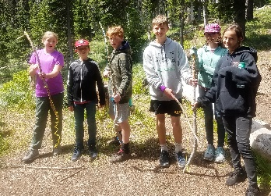
Arrive Community Bible Church by 8:30am, Friday, July 23th Bring a sack lunch for Friday, we’ll eat on the trail. The trail will be shorter this year, Nicole knows the way now. All teens will be returned to the same spot at 5pm to 6pm on Sunday, July 25th .

Cost: $25, this covers three meals a day with a snack in the evening, as well as other essentials for three days of camping fun.

Parents, please note:
For the good and safety of all the teens, we expect your teen to abide by the rules and regulations that have been established for the camp. If your child violates the rules and chooses not to cooperate and improve his/her behavior, we will contact you and expect you to pick them up at the trailhead. We cannot allow one teen to disrupt camp for others.

How to Visit-
Directions to the Lake: Driving up Nfd 9 (the North Fork of the CDA River) 39 miles. You will pass through Prichard and Murray. When you cross into MT the road is called Nfd 7 or Prospect Creek. You’ll drop into MT 1.5 miles and park on the right. Our rig will be visible from the paved road; silver truck w/ large silver horse trailer.

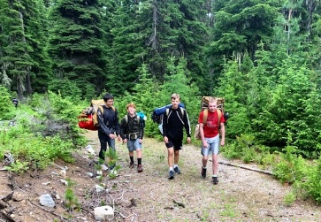
Camper Checklist:
- Sleeping bag, suggest leaving the pillow at home
- Tent – backpackable (suggest coordinating with others)
- Appropriate clothing (as specified in the NWCT Dress Code) for three days. Jacket – waterproof is good; Swimsuit if brave. Jeans required for Capture the Flag.
- Backpack (Call if you don’t have a hiking backpack I have extra; school packs do not work.)
- Hiking shoes, no sandals except for when you are going between your tent and the water.
- Personal care items: towels, washcloths, soap, shampoo, deodorant, toothbrush, toothpaste, comb, sunscreen, chapstick, insect repellent (lots of it), etc.
- Flashlight (Not the 4-D cell from dad’s pickup)
- Suggested items: small pocket knife, twine, fishing gear, hatchet, etc.
- Bring a Frisbee for playing golf, your losing too many of mine in the lake…

Items to be left at home:
Radios, tape/CD players/ipods, cell phones, electronic games, magazines, squirt guns, knives (other than pocket), large amounts of candy and snacks, gum, poor attitudes, anything that might get you into trouble.
Remember, you bring it, you pack it.

Gary and Tashia Dose
NORTHWEST CHRISTIAN TEENS, LLC / 1582 W.F. PINE CREEK RD. / PINEHURST, ID 83850
PHONE 1-208-682-4624 / EMAIL gwdose@pinecreekindustries.com

NWCT CAMP Guidelines

CAMP RULES:
1. Teens will be respectful and follow all reasonable instructions from Camp Leaders.
2. Teens will abide by all safety instructions and stay within the prescribed boundaries of the camp unless accompanied by an adult or permission is granted otherwise.
3. Teens will participate in camp activities with a willing, cheerful spirit that is honoring to the Lord.
4. Teens agree to maintain a friendly, respectful, Christian attitude towards everyone else in camp.

Teens understand that breaking these rules will result in the following: counseling, extra chores, loss of privileges, or even being escorted home for repeat or serious infractions.

NWCT BEHAVIOR/DRESS CODE
In order to maintain an environment that is honoring to the Lord in every way, members and leaders alike must follow the code. We are all expected to dress and act in a manner that reflects scriptural standards. Modesty, cleanliness, and appropriateness will then be the standard. Clothing which is too tight, too short, too loose, too low, or draws inappropriate attention to oneself and can be a distraction to those around us even though unintentional. Likewise, PDA (Public Displays of Affection), such as holding hands, hugging and pairing off in general will not be allowed. It should not be apparent that there are any “couples” in the group. Inappropriate dress and behavior that can mislead others are not honoring to the Lord.

NWCT staff reserves the right to determine the standard of the code. If needed, the teen may be asked to change. In all cases, the staff’s word will be final. If you have any questions concerning this please ask.

With this in mind the following code will be used and strictly enforced.

Dress:
- Bare midriff shirts, low neckline and open back shirts, halter-tops, and narrow thin straps, or tight fitting clothing are not allowed.
- No tank tops or sleeveless shirts that reveal any part of your undergarments or lack thereof.
- All shorts must be modest.
- No lewd clothing that exhibits alcohol, drugs, tobacco products, inappropriate language, or other offensive displays.
- If any article of clothing is questionable or you are in doubt, leave it home!

Behavior:
- No pairing off. A boy and a girl should not be together without others with them.
- No physical contact. This includes holding hands, hugging, etc.

+++++++++++++++++++++++++++
+++++++

Other good to know information:
Advance party will check out the lake ahead of time, I’ll update you on any changes

I’ll keep you up to date on who’s going so you all can coordinate tent arrangements.

Any parents are welcome to hike in to visit. Let me know if you can ahead of time so I can plan meals, but don’t let that stop you, we’ve never run out of food.

Pack light – you’ll have a better walk. I recommend packs not weigh more that 20-25 lbs. But you’re carrying it.
Make check payable to: NWCT
Mail completed application and camping fee to: NWCT, 1582 WF Pine Creek Rd., Pinehurst, ID 83850.
Camp Fees: $25 due by July 18th .

Please note any physical limitations, concerns, or information that may be helpful to us.

We, ____________________ (teen) and _______________ (Parent/Guardian) agree to abide by the NWCT rules and policies governing this activity and understand that we are responsible for the actions of our teen. We will be available to pick our child up at all times during this camp, whether for medical or disciplinary reasons. We agree not to hold NWCT liable for any services provided in good faith to us. We understand the dangers and risks involved in this activity and will assume full responsibility for any expenses our child may require, medical or otherwise. We further authorize the Camp Director to seek medical care for our child should the need arise.

Teen Signature ____________________________________

Parent/Guardian Signature ____________________________________

Date ____________________________________

